**DALIA project launches Rivers Revived Call for Associated Regions, inviting local and regional authorities to apply for a chance to secure a grant of up to 100K EUR for river restoration.**

DALIA's Open Call [**Rivers Revived**](https://www.dalia-danube.eu/index.php/opencall) presents a unique opportunity for local and regional authorities from Associated Regions[1] to participate in groundbreaking initiatives aimed at environmental, societal, and economic transformation. The Call aligns with DALIA's primary objectives, focusing on two key aspects: **knowledge transfer** and **solution** **scalability** for the Danube River Basin. In this regard, the Call is aiming to **replicate successful initiatives from** [**DALIA pilot sites (DPs)**](https://kms.dalia-danube.eu/pilot-sites/) into new pilot regions with similar conditions. By engaging local and regional authorities, the project aims to demonstrate the transferability, feasibility, and scalability of solutions for the Danube River.

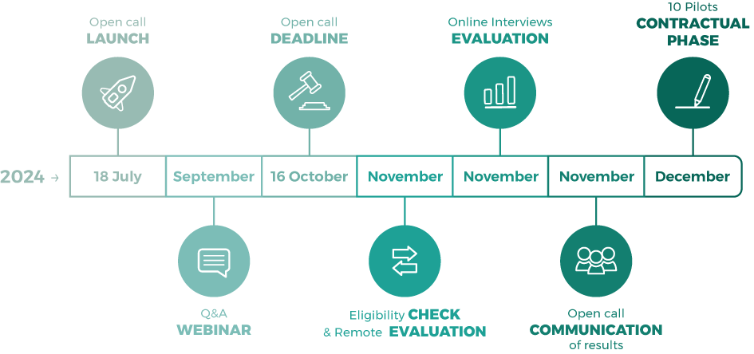

Applications for the Rivers Revived Call are **open until Wednesday, 16th October 2024, at 5 PM CET**.

DALIA expects to fund up to 10 projects from at least 5 different regions. **The maximum amount of financial support to each application will be limited to 100,000 EUR.**

**Join our Q&A Info Webinar:**

DALIA invites all interested parties to join its [Q&A Info Webinar](https://eu01web.zoom.us/webinar/register/WN_w-jkUJXZRdKG7qZPWIWS7A) on 18 September 2024, from 11 AM CET to 12:30 PM CET. This webinar will provide further insights into the **Rivers Revived Call**, including eligibility criteria, application process, and tips for a successful submission. Don't miss this opportunity to get all your questions answered and learn how to maximize your chances of securing funding for your project. **About the project:**

DALIA is a 48-month EU project which brings together 22 partners, committed to the environmental, societal, and economic transformation within the Danube River ​and freshwater complexes also supporting the new EU Mission: **Restore our Ocean and Waters by 2030.**

For more information regarding the Open Call, please contact:  
[opencall@dalia-danube.eu](mailto:opencall@dalia-danube.eu)

**Social Media Channels**

Facebook: <https://www.facebook.com/people/DALIA-Danube-Lighthouse/61551901064363/>

X: <https://twitter.com/DALIA_Project>

LinkedIn: <https://www.linkedin.com/company/dalia-danube-lighthouse/>

1. **The list of eligible countries can be found at:**[**https://www.dalia-danube.eu/index.php/opencall#**](https://www.dalia-danube.eu/index.php/opencall)